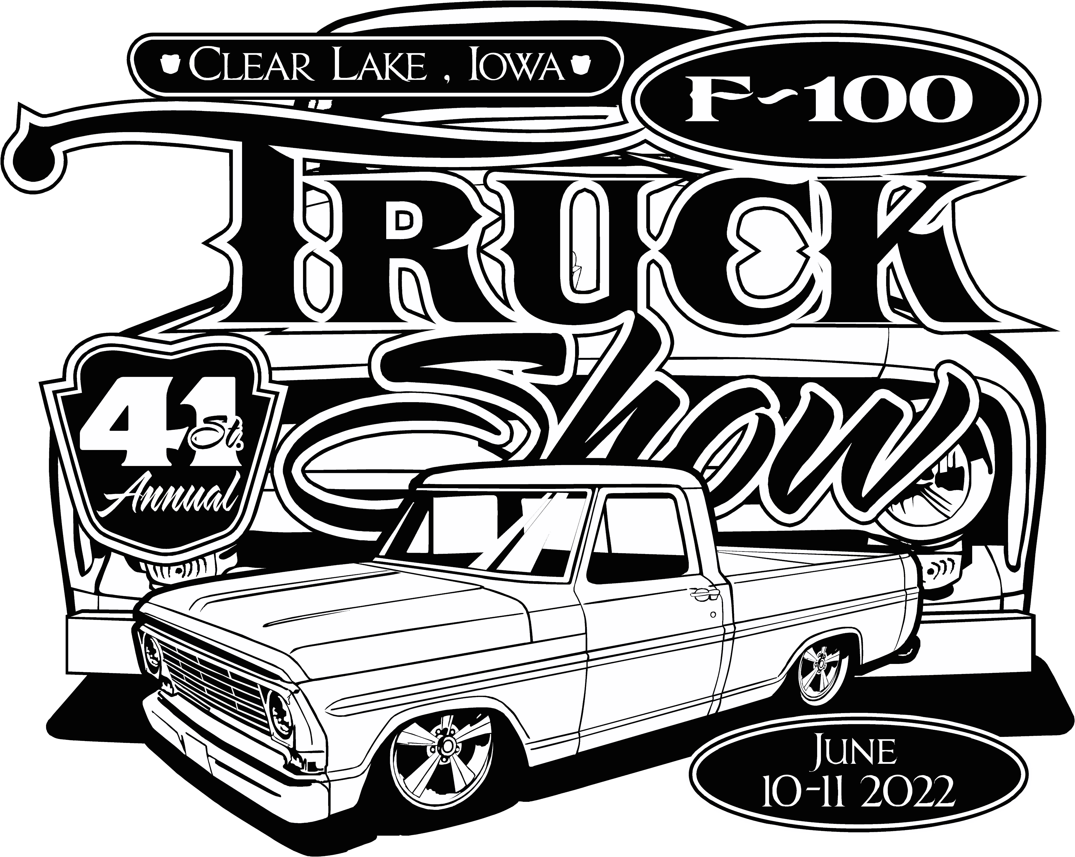
MARK YOUR CALENDARS FOR THE SECOND WEEKEND IN JUNE 10-11, 2022, FOR THE 41ST ANNUAL MIDWEST F-100 TRUCK SHOW IN BEAUTIFUL CLEAR LAKE IOWA. CLEAR LAKE IS LOCATED OFF HWY 35 IN NORTH CENTRAL IOWA. OPEN TO FORD TRUCKS THRU '79 AND ALL TRUCK ENTHUSIASTS. ENJOY THE CITY, GREAT MOTELS, AND WONDERFUL TRUCKS AND TRUCKERS.

-------- REGISTRATION FEE $25.00 --------

REGISTRATION WILL BE AT CITY PARK. IT WILL INCLUDE DOOR PRIZES, GOODIE BAGS, DASH PLAQUE, FRIDAY CRUISE AND EVENING HOT DOG ROAST, AND SATURDAY NOON PULLED PORK LUNCH.
THE FRIDAY CRUISE IS SCHEDULED TO BE A BOAT RIDE (WEATHER PERMITTING) ON THE BEAUTIFUL CLEAR LAKE ABOARD THE LADY OF THE LAKE PADDLEBOAT. ON SATURDAY, WE USUALLY CRUISE AROUND THE LAKE WITH A STOP IN VENTURA FOR ICE CREAM. ENJOY THE SCENERY WHILE LOOKING AT SOME GREAT TRUCKS AND CATCHING UP WITH YOUR FELLOW TRUCKERS. A FUN AWARDS CEREMONY CONCLUDES SATURDAY’S EVENTS.

HOTEL ACCOMMODATIONS PROVIDED BY:

AMERICINN 641-357-8954

A BLOCK OF ROOMS HAVE BEEN RESERVED FOR THIS F-100 EVENT AT THE AMERICINN, HOWEVER AVAILABILITY IS VERY LIMITED. GET YOUR RESERVATION NOW TO ENSURE YOU GET A ROOM. BE SURE TO TELL THEM YOU ARE WITH THE TWIN CITY F-100 TRUCK SHOW. OTHER HOTELS INCLUDE THE MICROTEL @ 641-357-0966, BEST WESTERN @ 641-357-5253, SUPER 8 @ 641-357-7521, AND BUDGET INN @ 641-357-8700.

IF YOU NEED ADDITIONAL INFORMATION, CALL PAT KOUKAL AT (651) 303-1537

